/usr/artifactory/artifactory-2.6.7

How NOT to Install Artifactory on Ubuntu
If you want to know how to install Artifactory on Ubuntu, I’d suggest skipping to the “How to Install Artifactory on Ubuntu” section, below. However, if you love to know exactly how to install Artifactory on Ubuntu kindly follow through the Artifactory installation instructions.
Development Server 1 has Ubuntu 12.04 and is running java 1.6. 0_45.

Download the artifactory zip or tar.gz release in http://sourceforge.net/projects/artifactory/files/artifactory/2.6.7/

After the download completes, unzip the file. Finish up the installation by moving the files to a convenient directory.
sudo mv artifactory-2.6.7 ~/path/to/artifactory

Note: Before you install its recommended to first verify your current environment by running artifactoryctl check under the $ARTIFACTORY_HOME/bin folder
By default its not executable, you need to issue a chmod command. Also, in order to execute the command we need to add an environment variable in the /.bashrc or /etc/bash.bashrc file.

sudo nano ~/.bashrc or sudo gedit ~/.bashrc

You can add this information to the end of the file:
export JAVA_HOME = <Your Java Home directory>
export CATALINA_HOME = /usr/artifactory/artifactory-2.6.7

Save and exit out of .bashrc. You make the changes effective by restarting the bashrc file or issue a source command.
. ~/.bashrc or source ~/.bashrc

artifactoryctl check
hosorioi@PH-CPGMN-DEVSRV1:/usr/artifactory/artifactory-2.6.7/bin$ sudo ./artifactoryctl check
Changed owner of /usr/artifactory/artifactory-2.6.7/logs/consoleout.log to artifactory
Artifactory is running, on pid=4983

Try to start the installation by running the $ARTIFACTORY_HOME/bin/install.sh script

hosorioi@PH-CPGMN-DEVSRV1:/usr/artifactory/artifactory-2.6.7/bin$ sudo ./install.sh

Installing artifactory as a Unix service that will run as user artifactory

Installing artifactory with home /usr/artifactory/artifactory-2.6.7
Creating user artifactory...creating... DONE

Checking configuration link and files in /etc/artifactory...
Moving configuration dir etc to etc.original DONE
creating dir /etc/artifactory...creating the link and updating dir... DONE
Creating environment file /etc/artifactory/default...creating... DONE
** INFO: Please edit the files in /etc/artifactory to set the correct environment
Especially /etc/artifactory/default that defines ARTIFACTORY_HOME, JAVA_HOME and JAVA_OPTIONS

Creating link /usr/artifactory/artifactory-2.6.7/logs to /var/log/artifactory...creating... DONE

Setting file permissions to etc, logs, work, data and backup... DONE

Copying the init.d/artifactory script...copying... DONE

Initializing artifactory service with update-rc.d...
update-rc.d: warning: artifactory start runlevel arguments (2 3 4 5) do not match LSB Default-Start values (3 4 5)
Adding system startup for /etc/init.d/artifactory ...
/etc/rc0.d/K20artifactory -> ../init.d/artifactory
/etc/rc1.d/K20artifactory -> ../init.d/artifactory
/etc/rc6.d/K20artifactory -> ../init.d/artifactory
/etc/rc2.d/S20artifactory -> ../init.d/artifactory
/etc/rc3.d/S20artifactory -> ../init.d/artifactory
/etc/rc4.d/S20artifactory -> ../init.d/artifactory
/etc/rc5.d/S20artifactory -> ../init.d/artifactory
DONE

************ SUCCESS *****************
Installation of Artifactory completed
you can now check installation by running:
> service artifactory check or
> /etc/init.d/artifactory check

Then activate artifactory with:
> service artifactory start or
> /etc/init.d/artifactory start
Installation of Artifactory completed. You can now check installation by running:
lservice artifactory check

Summary
- Make sure you’ve got Java 1.5 or above installed, and make a note of the full path, as you’re going to need this later.
- Download the artifactory zip and extract it somewhere.
- Go to your artifactory bin dir and make the install.sh file executable
- Now run sudo ./install.sh – this will copy some files around the place and setup some paths.
- Edit the file /etc/artifactory/default and put the FULL Java path in there as JAVA_HOME
- Make sure JAVA_HOME is also set in /etc/environment
- run “sudo service artifactory check”
- If it all looks good run “sudo service artifactory start”
- Go to http://localhost:8081/artifactory/
- You’re done!
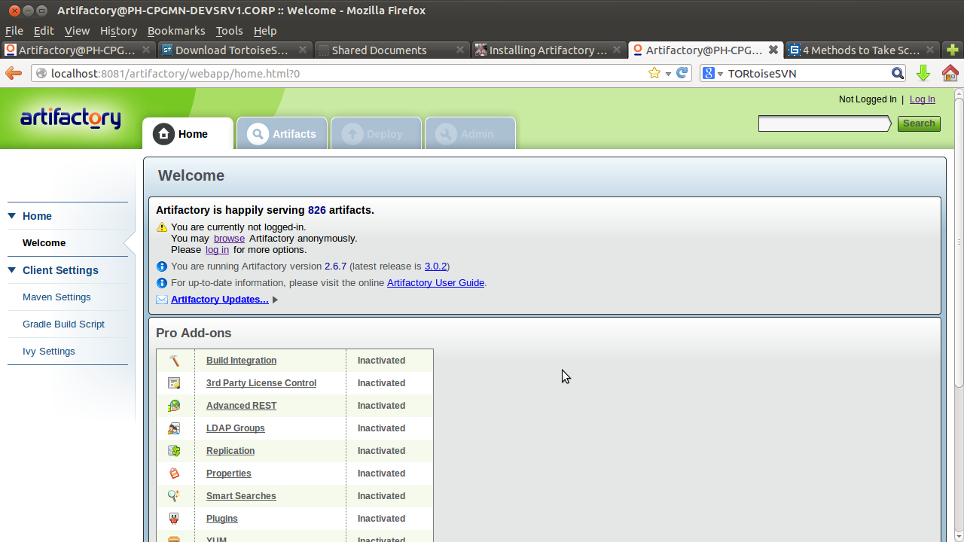

Integrating Maven and Artifactory

This procedure assumes that you have a working copy of Artifactory installed in your Ubuntu Server. If not you may want to read through “Maven Installation.odt”. It's a step by step guide on how to install Maven.

Getting Artifactory configuration for Maven.
Go http://servername:8081/artifactory/ and click “Maven Settings”. You'll see the screen shot below.
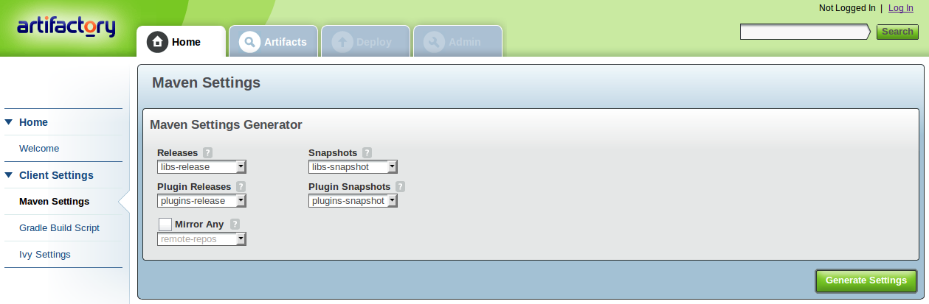
Click Generate Settings and copy/download the configuration script generated by Artifactory. It will serve as the team's common configuration to download and deploy artifacts to Artifactory.
A sample configuration file.
<?xml version="1.0" encoding="UTF-8"?>
<settings xsi:schemaLocation="http://maven.apache.org/SETTINGS/1.0.0 http://maven.apache.org/xsd/settings-1.0.0.xsd" xmlns="http://maven.apache.org/SETTINGS/1.0.0"
xmlns:xsi="http://www.w3.org/2001/XMLSchema-instance">

<mirrors>
<mirror>
<mirrorOf>*</mirrorOf>
<name>remote-repos</name>
<url>http://10.62.28.111:8081/artifactory/remote-repos</url>
<id>remote-repos</id>
</mirror>
</mirrors>
<servers>
<server>
<id>central</id>
<username>admin</username>
<password>password</password>
</server>
</servers>

<proxies>
<!-- proxy
| Specification for one proxy, to be used in connecting to the network.
| -->
<proxy>
<id>proxy</id>
<active>true</active>
<protocol>http</protocol>
<username>User CORP Username</username>
<password>your CORP Password</password>
<host>110.62.25.18</host>
<port>8080</port>
<nonProxyHosts></nonProxyHosts>
</proxy>
</proxies>

<profiles>
<profile>
<repositories>
<repository>
<snapshots>
<enabled>false</enabled>
</snapshots>
<id>central</id>
<name>libs-release</name>
<url>http://10.62.28.111:8081/artifactory/libs-release</url>
</repository>
<repository>
<snapshots />
<id>snapshots</id>
<name>libs-snapshot</name>
<url>http://10.62.28.111:8081/artifactory/libs-snapshot</url>
</repository>
</repositories>
<pluginRepositories>
<pluginRepository>
<snapshots>
<enabled>false</enabled>
</snapshots>
<id>central</id>
<name>plugins-release</name>
<url>http://10.62.28.111:8081/artifactory/plugins-release</url>
</pluginRepository>
<pluginRepository>
<snapshots />
<id>snapshots</id>
<name>plugins-snapshot</name>
<url>http://10.62.28.111:8081/artifactory/plugins-snapshot</url>
</pluginRepository>
</pluginRepositories>
<id>artifactory</id>
</profile>
</profiles>
<activeProfiles>
<activeProfile>artifactory</activeProfile>
</activeProfiles>
</settings>

Described in document are the various virtual repositories available with Artifactory. You need to copy this configuration to your M2_HOME\conf\setting.xml. Your local Maven installation should now use the repositories indicated above and will accordingly download necessary dependencies as needed outside your local network to the internet.

Testing the configuration
Execute a mvn deploy or mvn install and check if the applicable servername/ip address is being utilized by Maven.

